

**SAVEETHA SCHOOL OF ENGINEERING**

**SAVEETHA INSTITUTE OF MEDICAL AND TECHNICAL SCIENCES**

**CHENNAI-602105**

# Online Bakery Bliss Delivery

**A CAPSTONE PROJECT REPORT**

*Submitted in the partial fulfillment for the award of the degree of*

**BACHELOR OF ENGINEERING**

**IN**

**COMPUTER SCIENCE AND ENGINEERING**

**Submitted by**

**K.Rupesh Reddy(192210426)**

**M.Vamsi(192211903)**

**M.Prudhvi (192211674)**

**Under the Supervision of**

**Dr. K. Jayasakthi Velmurugan**

**NOVEMBER 2024**

## DECLARATION

We,**K.Rupesh Reddy , M.Vamsi, M.Prudhvi,** students of

**Bachelor of Engineering in the Department** of Computer Science and

Engineering, Saveetha Institute of Medical and Technical Sciences, Saveetha

School of Engineering, Chennai, hereby declare that the work presented in this Capstone Project Work entitled **Online Bakery Bliss Delivery** is the outcome of our own bonafide work and is correct to the best of our knowledge and this work has been undertaken taking care of Engineering Ethics.

(K.Rupesh Reddy 192210459)

(M.Vamsi 192211903)

(M.Prudhvi 192211674)

Date:11-12-2024

Place:Chennai

## CERTIFICATE

This is to certify that the project entitled **“Online Bakery Bliss Delivery”** submitted by **K.Rupesh Reddy, M.Vamsi, M.Prudhvi** has been carried out under my supervision. The project has been submitted as per the requirements in the current semester of B.E Computer Science Enginnering.

Teacher-in-charge

Dr. K. Jayasakthi Velmurugan

# Table of Contents

|  |  |  |
| --- | --- | --- |
| **S.NO** | **TOPICS** | **Page no:** |
| 1 | **Abstract** | **4** |
| 2 | **Introduction** | **5** |
| 3 | **Project Description** | **6** |
| 4 | **Problem Description** | **6** |
| 5 | **Tool Description**  User interface  Features | **7** |
| 6 | **Operations** | 8 |
| 7 | **Approach / Module Description / Functionalities** | **8** |
| 8 | **Implementation** | **8-14** |
| 9 | **Output** | **15-18** |
| 10 | **Conclusion References** | **16-17** |

**ABSTRACT**

The Online Bakery Bliss Delivery System is a sophisticated web-based application developed to simplify and enhance the ordering and delivery process for both customers and bakery managers. This system allows users to browse a variety of baked goods, check real-time availability, customize orders, and schedule deliveries, providing a convenient and seamless shopping experience. For bakery managers, it offers an efficient platform to manage orders, track inventory, and optimize delivery schedules, improving operational workflow and reducing errors. By integrating these functionalities, the system aims to increase customer satisfaction, streamline order processing, and drive business growth.

Additionally, the system’s analytics capabilities provide valuable insights into customer preferences, peak ordering times, and sales trends, empowering bakeries to make data-driven decisions and tailor offerings to meet customer demand. Through a user-friendly interface, customers can access the system across devices, offering a consistent experience on both desktop and mobile platforms.

The Online Bakery Bliss Delivery System is crafted to meet the evolving demands of modern consumers, who increasingly seek convenience, personalization, and fast delivery. This system’s interactive catalog allows customers to filter items by categories such as cakes, pastries, bread, and seasonal items, with detailed descriptions and images for each product. Additionally, customers can customize orders, select preferred delivery windows, and access ongoing promotions, enhancing their shopping experience. The real-time order tracking feature keeps customers informed at every stage of the process, from order placement to delivery, providing transparency and reducing waiting anxiety. By focusing on user convenience and offering a seamless online experience, the system caters to the needs of busy consumers, ultimately improving customer loyalty and satisfaction.

For bakery managers and staff, the system provides robust tools to streamline and automate daily operations. Through the admin panel, staff can view incoming orders, track ingredient usage, and monitor inventory to ensure they meet customer demand without overstocking. The system also offers automated notifications and reminders for customers regarding upcoming delivery times, order statuses, and any changes, which helps reduce the likelihood of missed deliveries and enhances the customer experience. Analytics features allow managers to analyze customer behavior, identify peak ordering periods, and track popular items, enabling strategic planning and efficient resource allocation. With its data-driven insights, the Online Bakery Bliss Delivery System supports bakery managers in making informed business decisions and refining their product offerings to better align with customer preferences. This comprehensive approach not only improves operational efficiency but also empowers bakeries to deliver a consistent, high-quality experience that keeps customers coming back.

**INTRODUCTION**

In today’s digital age, the food industry faces increased pressure to provide convenient, efficient, and personalized services to meet the demands of modern consumers. As online shopping becomes a staple for purchasing various goods, customers increasingly expect the same level of convenience when ordering baked goods. Traditional methods of ordering, such as phone calls or in-store visits, can be time-consuming and prone to errors, limiting customer satisfaction and creating inefficiencies in order management. Such challenges, especially during peak times or holiday seasons, often lead to delayed orders, missed requests, and unsatisfied customers, impacting the bakery’s reputation and customer loyalty.

To address these challenges, the Online Bakery Bliss Delivery System offers an all-in-one platform that enables customers to browse products, customize orders, and schedule deliveries directly through a website or mobile app. With real-time inventory updates, flexible delivery scheduling, and secure online payments, customers enjoy a seamless and efficient ordering experience, reducing dependency on traditional methods and minimizing human error. The platform’s design caters to both desktop and mobile users, providing accessibility and convenience, which aligns with the digital habits of today’s tech-savvy clientele. By transforming the ordering and delivery process, the system supports bakeries in offering a smooth, customer-centric experience that enhances satisfaction and strengthens brand loyalty.

From the bakery’s perspective, this system goes beyond order management by providing analytical tools that enable staff to track customer preferences, identify high-demand products, and monitor peak ordering times. These insights allow bakery managers to make strategic decisions on product offerings, optimize inventory, and plan promotional activities more effectively. Additionally, the system automates order tracking and sends notifications to both staff and customers, reducing missed orders and helping manage order queues efficiently. By streamlining daily operations, the Online Bakery Bliss Delivery System frees up staff to focus on quality production and customer service, ultimately helping bakeries maintain a competitive edge in a rapidly evolving market. This project aims to deliver a comprehensive digital solution that not only improves operational efficiency but also enhances the overall customer experience, setting a new standard for convenience and satisfaction in the bakery industry.

**PROJECT DESCRIPTION:**

The Online Bakery Bliss Delivery System is a web application designed to simplify the ordering and delivery process for customers and bakery managers alike. Key features include:

● **\*\*User Interface**:** A clean and intuitive interface that allows customers to browse a wide variety of baked goods, select products, and customize orders. The interface is designed to be responsive, ensuring a seamless experience across all devices, including smartphones, tablets, and desktops.

● **\*\*Real-Time Inventory and Availability\*\***: Real-time updates on product availability to prevent ordering issues and ensure that customers receive accurate information. This feature helps manage stock levels efficiently and prevents over-selling, ensuring customer satisfaction.

● **\*\*User Accounts**:** Options for customers to create personal accounts, enabling quicker reorders, saving payment details, and tracking past purchases. Returning customers can enjoy a personalized shopping experience, with easy access to their order history and favorite items.

● **\*\*Notifications**:** Automated email and SMS notifications to confirm orders, provide delivery updates, and remind customers of their upcoming deliveries. These notifications help ensure timely deliveries and enhance the overall customer experience by keeping them informed throughout the order process.

● **\*\*Admin Dashboard**:** A comprehensive dashboard for bakery managers to manage orders, track inventory, monitor sales trends, and optimize delivery schedules. The admin panel allows for easy order management, inventory updates, and customer communication, helping bakery staff efficiently manage day-to-day operations.

This system provides both customers and bakery managers with an efficient, user-friendly platform that improves convenience, order accuracy, and operational efficiency, ultimately creating a superior online bakery shopping experience.

**OVERVIEW:**

The goal is to design and implement a web-based Online Bakery Bliss Delivery. This system will allow customers to book cakes online, and bakery staff to manage bookings efficiently. The system should handle customer reservations, track order availability, and provide a userfriendly interface for both customers and staff.

**FEATURES:**

\*\***Customer Features**:**

**\*\*User Registration and Login**:** Customers can create an account and log in to the system for a personalized experience, including faster checkout and access to order history.

**\*\*Browse Products**:** Customers can browse a variety of baked goods, including cakes, pastries, bread, and seasonal items. They can view detailed descriptions, prices, and images of each product.

**\*\*Place Order\***\*: Customers can select items, customize them (e.g., cake flavors, frosting, size), and add them to their cart. They can choose the delivery date and time..

**View Order Status**: Customers can track their order status, including order confirmation, preparation, and delivery updates.

**Cancel or Modify Order**: Customers can cancel or modify their orders, provided it is within a specified time frame before the delivery.

**Bakery Staff Features:**

● \*\***Staff Login**\*\*: Bakery staff can log in to the system to manage orders and customer requests.

● \*\***Manage Orders**\*\*: Staff can view all incoming orders, confirm them, modify items if necessary, and update order status (e.g., in progress, ready for delivery).

● **\*\*Track Inventory**:** Bakery staff can monitor inventory levels and update product availability in real-time to avoid accepting orders for out-of-stock items.

**Tool Description:**

To develop this system, various tools and technologies will be utilized:

* **Front-End:** HTML, CSS, JavaScript, and frameworks like React or Angular for a responsive user interface. These technologies ensure that the front-end is dynamic, interactive, and provides a seamless user experience.
* **Back-End:** Node.js, Express.js, or Django for server-side logic. These back-end frameworks facilitate efficient handling of requests, data processing, and integration with the database.
* **Database:** MySQL, PostgreSQL, or MongoDB for storing reservation data. A robust database system is essential for managing and retrieving reservation data efficiently.
* **APIs:** Integration of third-party APIs for email/SMS notifications. These APIs ensure reliable and timely communication with customers.
* **Hosting:** Deployment on platforms like AWS, Heroku, or DigitalOcean. These cloud hosting services provide scalability, reliability, and security for the application.

**Operations:**

The operations of the Online Bakery Bliss Delivery System can be divided into the following stages:

**1. Customer Interaction:** Customers visit the website or app, browse available baked goods, customize items if needed (e.g., flavors or sizes), add products to their cart, and select a delivery date and time. This process is designed to be smooth and user-friendly, enhancing the shopping experience**.**

**2. Order Processing:** The system checks product availability in real-time, processes the order, and updates inventory. This step ensures that orders are accurately recorded and that only available items are shown to customers, preventing out-of-stock issues.

**3. Confirmation and Notification:** Customers receive order confirmation via email or SMS, detailing the items ordered, delivery date, and estimated time. These notifications keep customers informed and provide them with a clear record of their purchase.

**4. Order Fulfillment and Delivery Management:** Bakery staff use the admin dashboard to view and manage incoming orders, prepare items for delivery, and schedule deliveries. Staff can track delivery statuses and make any necessary adjustments, ensuring timely fulfillment and customer satisfaction.

**5. Data Analytics:** The system provides insights into sales and customer preferences, including popular products, peak order times, and seasonal trends. These analytics help bakery managers make data-driven decisions on inventory management, product offerings, and promotions to boost sales and customer satisfaction. Approach / Module Description / Functionalities:

**MODULE**

The system is divided into several modules, each handling specific functionalities:

Modules of the Online Bakery Bliss Delivery System:

1**. User Module**: Manages user accounts, authentication, and profile information. This module ensures secure access and a personalized experience for customers, including quick access to past orders and saved preferences.

2. **Order Module**: Handles the ordering process, including product browsing, customization, inventory checks, and order placement. This core module ensures a smooth and reliable ordering experience, updating product availability in real-time.

3. **Notification Module**: Manages email and SMS notifications for order confirmations, status updates, and delivery reminders. This module ensures effective communication with customers, helping to build trust and reduce missed deliveries.

4. **Admin Module:** Provides tools for bakery staff to manage orders, update inventory, and schedule deliveries. The module streamlines order management and allows staff to view customer orders, optimize delivery routes, and make any necessary adjustments.

5. **Reporting Module**: Generates reports on sales trends, popular products, peak ordering times, and customer preferences. These reports provide valuable insights for strategic decision-making, helping bakery managers refine offerings and improve customer satisfaction.

**IMPLEMENTATION:**

IMPLEMENTATION for Online Bakery Bliss Delivery:

**1. Registration:** The user fills out a registration form on the frontend (HTML/CSS/JavaScript). The form data is sent to the web server (PHP) via an HTTP POST request. The PHP script validates the data (e.g., email format, password strength) and, upon successful validation, inserts the user information into the database, creating a new account.

**2. Login:** The user enters their credentials on the login form on the frontend. The credentials are sent to the web server (PHP) via an HTTP POST request. The PHP script verifies the credentials against the database and, if correct, initiates a session for the user, granting access to personalized features.

**3. Product Selection and Order Placement:** The logged-in user browses products and customizes options on the frontend. When ready, the user adds items to their cart and proceeds to checkout. The order details are sent to the web server (PHP) via an HTTP POST request. The PHP script processes the order, confirms product availability, and stores the order details in the database.

**4. Order Confirmation and Payment:** The PHP script generates an order summary and displays available payment options on the frontend. Upon payment completion, the system updates the order status, generates a unique order ID, and stores payment confirmation details. An order confirmation is sent to the user via email or SMS.

**5. Order Tracking and Notifications:** The system provides real-time order status updates on the frontend. Automated email/SMS notifications inform the user at each stage (e.g., order confirmed, out for delivery). The PHP script manages these notifications and sends updates as the order progresses, ensuring customers stay informed.

**6. Admin Order Management**: Bakery staff log in to an admin dashboard, where they can view, confirm, and update order statuses. The PHP script retrieves order details from the database and displays them for easy management. Staff can adjust delivery times, check inventory, and update order statuses, streamlining the order fulfillment process.

**CODE:**

**REGISTER.HTML:**

<!DOCTYPE html>

<html lang="en">

<head>

<meta charset="UTF-8">

<meta name="viewport" content="width=device-width, initial-scale=1.0">

<title>Register | </title>

<style>

body {

font-family: Arial, sans-serif;

margin: 0;

padding: 0;

box-sizing: border-box;

background-color: f4f4f4#;

}

.container {

max-width: 500px;

margin: 50px auto;

padding: 20px;

background: blue;

border-radius: 8px;

box-shadow: 0 4px 8px rgba(0, 0, 0, 0.1);

}

h1 {

font-size: 28px;

margin-bottom: 20px;

color: #333;

text-align: center;

}

label {

display: block;

margin: 10px 0 5px;

font-weight: bold;

}

input[type="text"], input[type="email"], input[type="password"] {

width: 100%;

padding: 10px;

margin: 5px 0 20px;

border: 1px solid #ddd;

border-radius: 5px;

}

.btn {

background: #ff6f61;

color: #fff;

border: none;

padding: 10px 20px;

cursor: pointer;

border-radius: 5px;

font-size: 16px;

transition: background 0.3s ease;

width: 100%;

}

.btn:hover {

background: #e65c50;

}

.message {

text-align: center;

color: #d44;

}

</style>

</head>

<body>

<div class="container">

<h1>Register</h1>

<form id="register-form">

<label for="username">Username</label>

<input type="text" id="username" name="username" required>

<label for="email">Email</label>

<input type="email" id="email" name="email" required>

<label for="password">Password</label>

<input type="password" id="password" name="password" required>

<button type="submit" class="btn">Register</button>

<div id="message" class="message"></div>

</form>

</div>

<script>

document.getElementById('register-form').addEventListener('submit', function(event) {

event.preventDefault();

const username = document.getElementById('username').value;

const email = document.getElementById('email').value;

const password = document.getElementById('password').value;

const messageElement = document.getElementById('message');

messageElement.textContent = 'Registration successful! Redirecting to homepage...';

messageElement.style.color = '#4caf50';

setTimeout(() => {

window.location.href = 'Register.html';

}, 2000);

});

</script>

</body>

</html>

**LOGIN.PHP:**

<?php

$servername = 'localhost';

$username = 'root';

$password = '';

$dbname = "restaurant"; // Corrected spelling

// Create connection

$conn = new mysqli($servername, $username, $password, $dbname);

// Check connection

if ($conn->connect_error) {

    die("Connection failed: " . $conn->connect_error);

}

if ($_SERVER["REQUEST_METHOD"] == "POST") {

    $user = isset($_POST['f_name']) ? $_POST['f_name'] : '';

    $reg = isset($_POST['reg_no']) ? $_POST['reg_no'] : '';

    $email = isset($_POST['email']) ? $_POST['email'] : '';

    $pass = isset($_POST['pws']) ? $_POST['pws'] : '';

    $phone = isset($_POST['phone']) ? $_POST['phone'] : '';

    $country = isset($_POST['country']) ? $_POST['country'] : '';

    $html_page_url = "fd.html";

    $linked_word = "For Food";

    // Prepare and bind SQL statement

    $stmt = $conn->prepare("INSERT INTO table2 VALUES (?, ?, ?, ?, ?, ?)");

    $stmt->bind_param("sissis", $user, $reg, $email, $pass,$phone,$country);

    // Execute

    if ($stmt->execute()) {

        echo "<span class='success-message'>Booked successfully</span>";

        echo "<a href='$html_page_url'>$linked_word</a>";

    } else {

        echo "Error: " . $stmt->error;

    }

    $stmt->close();

}

$conn->close();

?>

**OUTPUT:**

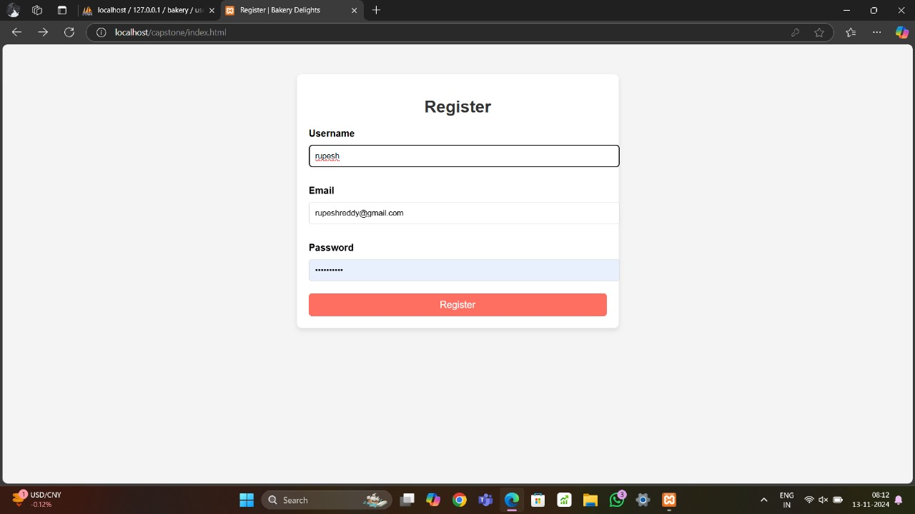

Fig 1:Registration Form

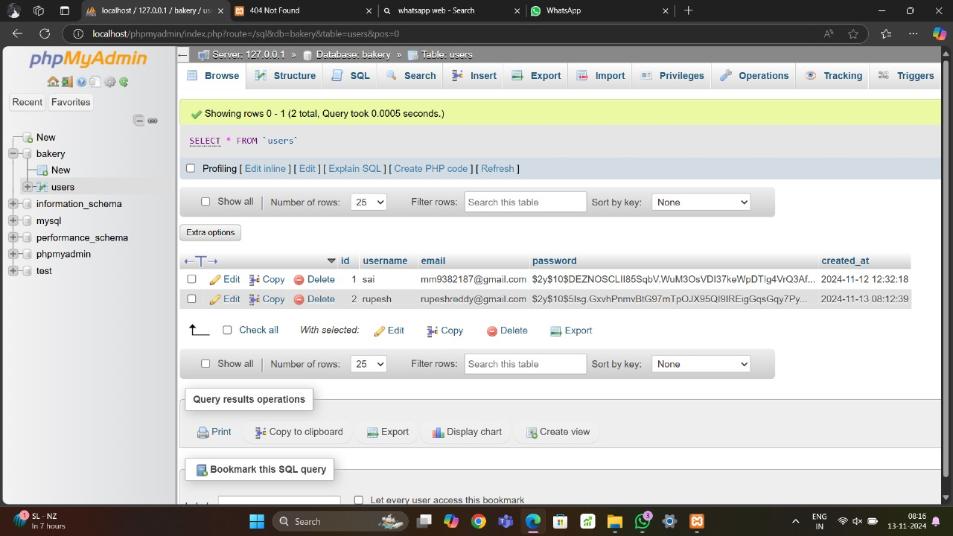

Fig 2:Database of Table 1.

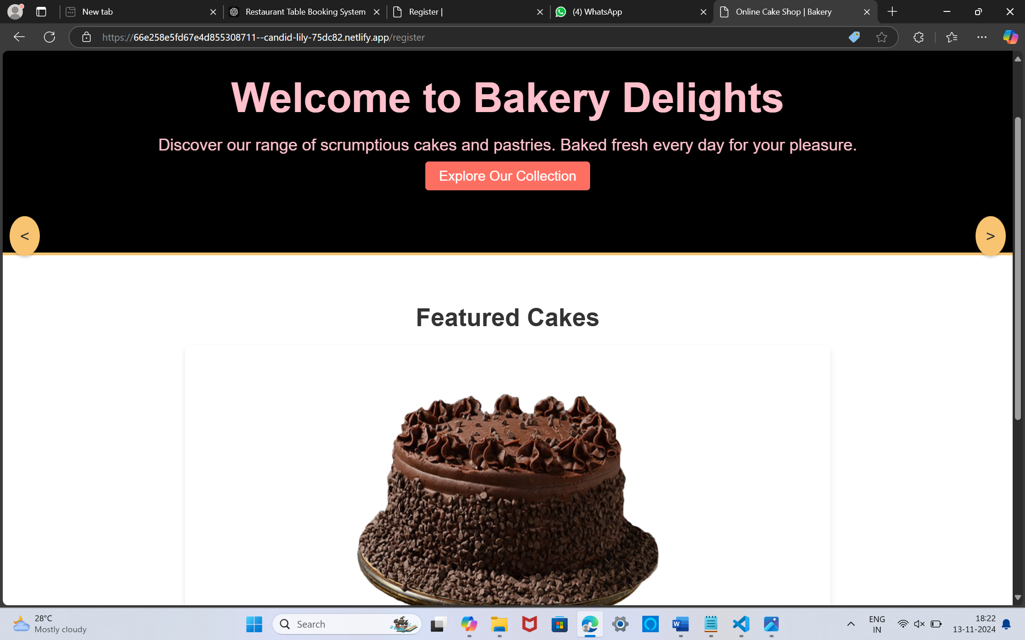

Fig 3:home page

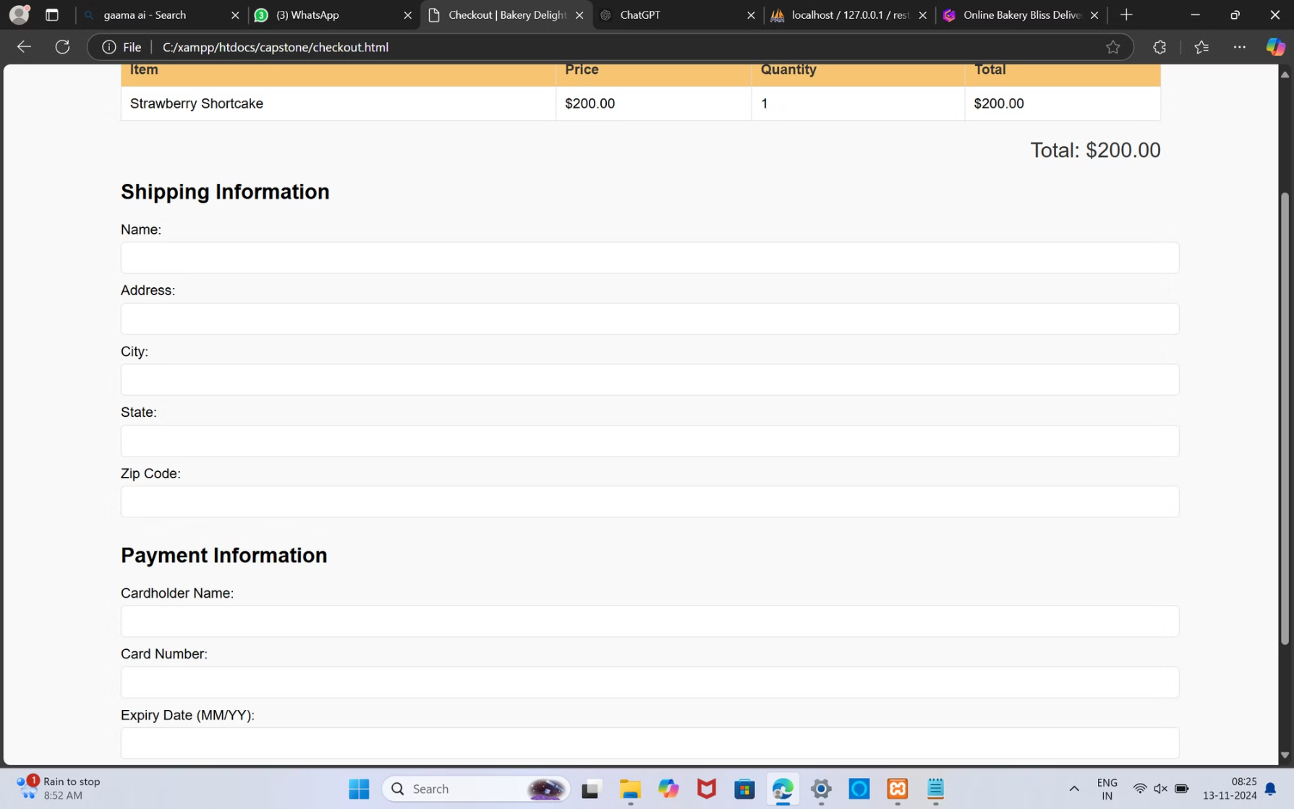

Fig 4:ordering page

**Conclusion:**

Online Bakery Bliss Delivery System offers a seamless, efficient solution for both customers and bakery staff, transforming the way baked goods are ordered and delivered. By providing a user-friendly interface, real-time inventory management, and convenient order tracking, the system enhances the customer experience and meets the growing demand for digital convenience in the food industry. For bakery staff, the system streamlines order management, optimizes inventory, and automates notifications, which reduces manual tasks and allows staff to focus on quality service and product preparation.

**References:**

1. Kumar, B. Naveen, and B. Sai Varun. "Table booking and restaurant management system using android application (OPSS)." *International Journal of Engineering Applied Sciences and Technology* 4.12 (2020): 373-378.

1. Balabantaray, Sidhanta Kumar, et al. "Online Table and Menu Booking System for Restaurants."

1. Rarh, Fahim, et al. "Restaurant table reservation using time-series prediction." *2017 2nd International Conference on Communication and Electronics Systems (ICCES)*. IEEE, 2017.

1. Egigogo, Raji Abdullahi, et al. "Design and Implementation of Computerized Restaurant Table Booking System." *Ceddi Journal of Information System and Technology (JST)* 3.1 (2024): 47-55.

1. Kale, Sharyu, Parth Goti, and Reema C. Roychaudhary. "Online Table and Menu Booking System for Restaurants."

1. Ardiansyah, Muhammad Rizqi, et al. "The Website-Based Food Booking System Equipped with Real-Time Booking Status to Address Queuing Issues at Restaurants." *2021 International Conference on Electrical and Information Technology (IEIT)*. IEEE, 2021.

1. AL, Zuwaina Said AL Housni Said, et al. "Reserve your table: A mobile application for reservations in a restaurant." *Journal of Student Research* (2021).

1. Gregorash, Bill J. "Restaurant revenue management: apply reservation management?." *Information Technology & Tourism* 16 (2016): 331-346.

1. Sethi, Akash, et al. "Review paper on restaurant reservation and management." *International Journal Of Progressive Research In Engineering Management And Science (Ijprems)(pp: 141147)* (2022).

**10.**Soo, Huey Ling. Restaurant ordering and reservation system/Soo Huey Ling. Diss. University of Malaya, 20